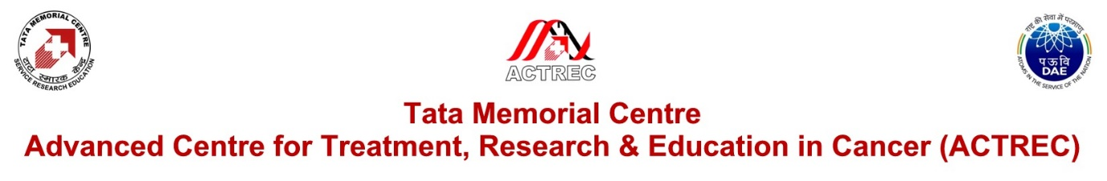

In partial modification of the Expression of Interest, No. ACTREC/EOI/2018-2019/02, dated 29th January, 2019, available at [http://www.actrec.gov.in/data files/Tenders/2019/EOI-HPC-20190129.doc](http://www.actrec.gov.in/data%20files/Tenders/2019/EOI-HPC-20190129.doc) under ‘General terms and conditions, point 3 (page 17), point 7 & 15 (page18)’, the Competent Authority has decided to invite all eligible bidders (full public tender) for the following project: “Expression of Interest for Short listing the prospective competent bidders (individual or in group) for A) design, site preparation, supply, installation , testing, commissioning , operations & maintenance of proposed infrastructure (Data centre) with HPC facility for 5 years (3 years warranty + 2 years CMC) on Turnkey basis AND B) Design, Planning, Engineering, Procurement & Construction services for the I.T. office complex, which consists of modern amenities, in Proposed for Computational Biology Centre at ACTREC campus located at Navi Mumbai.”. The tender for this project will be issued shortly. All interested parties are requested to note this information.

Link to original EOI: [http://www.actrec.gov.in/data files/Tenders/2019/EOI-HPC-20190129.doc](http://www.actrec.gov.in/data%20files/Tenders/2019/EOI-HPC-20190129.doc)

Link to modification notice: <https://actrec.gov.in/sites/default/files/2020-01/EOI-HPC-20200124.doc>