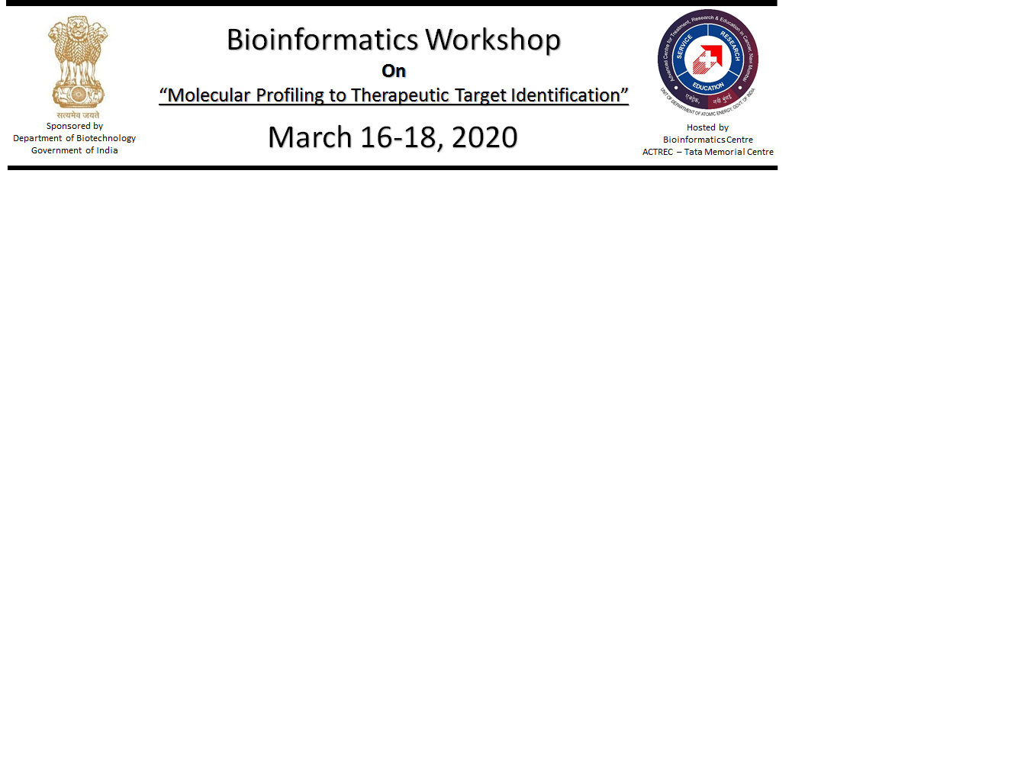

Name

Designation

Institutional affiliation

Institutional Address

Phone: Workplace/Mobile
Email:

Educational Qualifications
(1)M.Sc or (2)PhD

Current Area of Research

Why are you interested to attend the Workshop? Any other similar meeting attended?

Name, designation and address of the competent authority granting permission (along-with his/her telephone, fax and E-mail address).

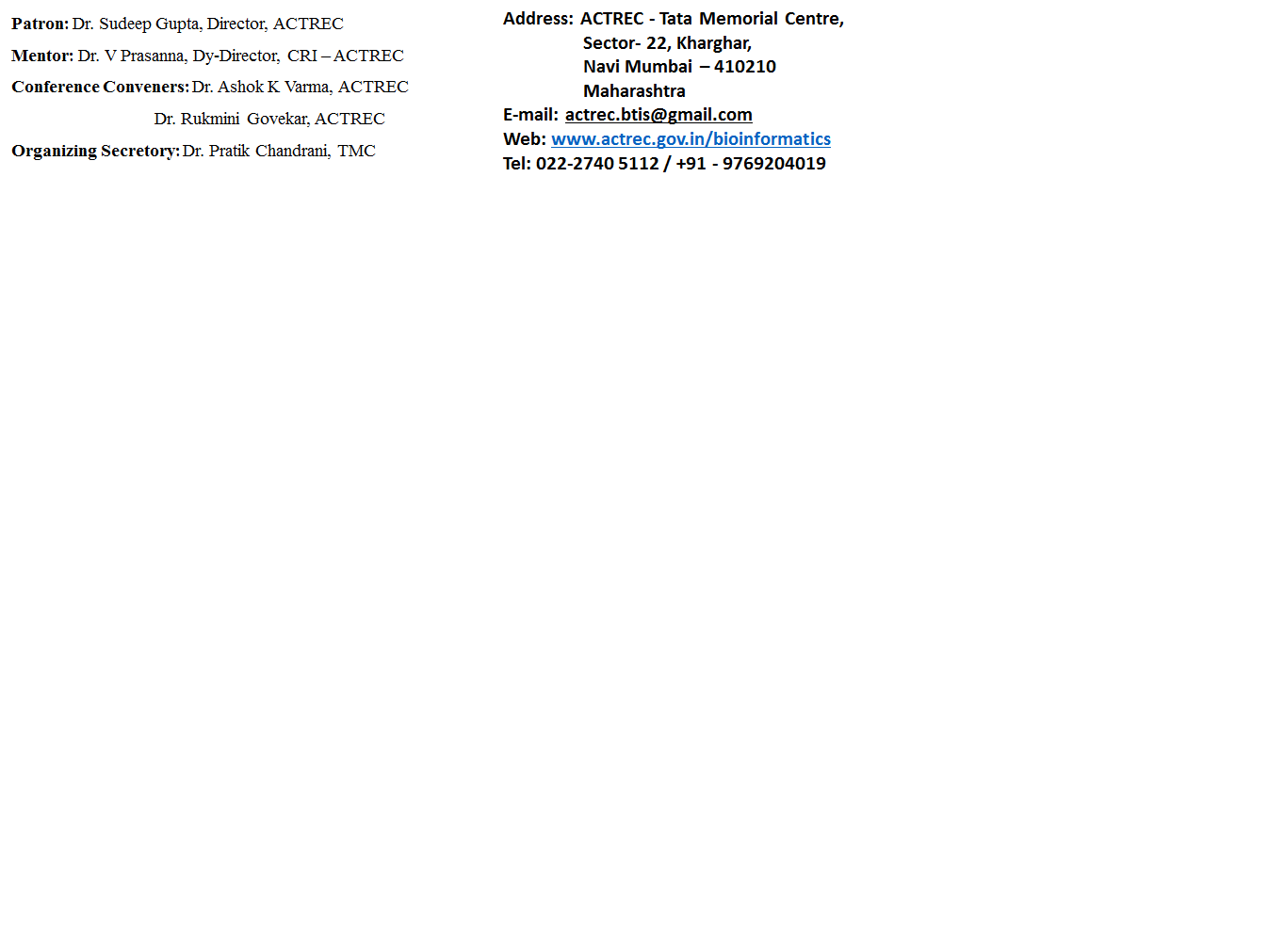

Last date for receipt of application: 5th March 2020

